**CURRICULAM VITAE**

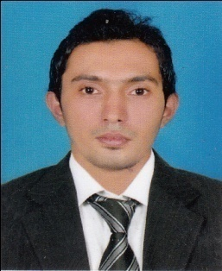**SHAKKEEL V**

Aamaattu paramba

Kambiliparamba

Olavanna po

calicut -673019

**Mob: 9746381419**

**Email :** [**shakkeelfayz@gmail.com**](mailto:shakkeelfayz@gmail.com)

**Career Objective**

Every assignment taken up by me, I consider it as a unique opportunity to create and add value to my own career through a hands on learning approach that contributes to the growth of the organization.

**Professional Experience**

1, **J**uly 2013– Till date : **Axis bank Ltd.**

Zuhara arcade,aratt road,kannur

Designation  : Sales officer

2,April 2011-July 2013  **:Hdfc bank Ltd**

:simax tower,vandippetta,calicut

Designation :Sales Executive

**Duties & Responsibilities**

• **Sales Officer in edc department**.

* **Acquiring & Maintaining business**
* **Developing the market & business**
* **Maintaining good business relationship**

**Educational Qualification**

|  |  |  |  |
| --- | --- | --- | --- |
| **Year** | **Institution** | Course | Marks |
| 2008-2011 | Calicut University , Kozhikode. | B.Com  (Calicut University) | 49% |
| 2005-2007 | Privet study | Plus 2  ( HSE) | 62% |
| 2002-2003 | G.v.h.s.s kinassery , Kozhikode. | S.S.L.C | 40.00% |

**Technical Qualification**

* Certificate course in **Tally ERP 9** From Manvish Acadamy
* Certificate Course in **Desk Top Publishing Course ( DTP**) From skill Development Center

**Software Proficiency**

* Proficient in usage of Ms Office.
* Tally ERP 9
* DTP

**Strengths**

* Excellent communication skills
* Positive attitude and time Management
* Sound leadership skills
* Good team player
* Adaptive to any situations

**Languages Known**

**Read & Write** : English, Malayalam,

**Converse**  : English, Malayalam,

**Personal Profile**

Name : Shakkeel v

Father’s name : Moideen Koya v

Date of Birth : 1st  March .1988

Gender : Male

Marital Status : Single

Nationality : Indian

**Declaration**

I hereby declare that the above furnished details are true to the best of my knowledge

Yours faithfully,

**Place: Kozhikode**

Date: 16/04/2015 **Shakkeel v**